
Dashboard Design

Date | 24 September 2024
Team ID | PNT2022TMIDxxxxxx
Project Name | Electric Vehicle Market Performance & Insights
Maximum Marks | 5 Marks

Creating an effective dashboard involves thoughtful design to ensure that the presented information is clear, relevant, and easily understandable for the intended audience. Here are some key principles and best practices for dashboard design
Activity 1: Interactive and Visually Appealing Dashboards
Creating an effective dashboard involves presenting data in a clear, organized, and interactive manner. In this project, Tableau is used to develop an interactive Electric Vehicle Market Dashboard that provides insights into EV sales, manufacturers, vehicle categories, battery technologies, and manufacturing locations.
The dashboard combines different visualizations to help users understand EV market performance and explore important business insights.

Dashboard Design Principles
1. Clear and Intuitive Layout
The dashboard organizes the seven visualizations in a structured layout so users can easily understand and compare different aspects of the EV market.
2. Use Appropriate Visualizations
Different chart types are used according to the data and business questions, including bar charts, donut charts, line charts, maps, scatter plots, and treemaps.
3. Colour and Theming
Suitable colours are used to distinguish data categories, manufacturers, and other EV-related information, making the dashboard visually appealing and easier to interpret.
4. Interactive Filters and Slicers
Interactive filters are provided for:
- Manufacturer
- Vehicle Category
- Manufacturing Country
These filters allow users to explore specific information according to their requirements.
5. Drill-Down Capabilities
Users can explore individual data points and categories through Tableau's interactive chart features and tooltips.
6. Responsive Design
The dashboard layout is arranged to make the visualizations accessible and understandable. The published dashboard can be viewed through Tableau Public.
7. Custom Visuals and Icons
Different visualization types, chart titles, labels, and legends are used to present EV market information effectively.
8. Use of Infographics
The dashboard combines multiple visual representations to communicate important EV market trends and insights in an understandable format.

Major Outcomes of the Dashboard
The dashboard provides the following major outcomes:
- Manufacturer Performance: Identifies and compares EV sales across different manufacturers.
- Category Analysis: Highlights the contribution of different EV vehicle categories to total sales.
- Yearly Sales Trends: Shows changes in EV sales over different years.
- Battery Technology Analysis: Compares annual sales across different battery technologies, including LFP, NMC, NCA, Sodium-Ion, and Solid-State.
- Manufacturing Distribution: Provides insights into the geographical distribution of EV manufacturing across countries.
- Price and Sales Relationship: Uses a scatter plot to explore the relationship between EV prices and annual sales units.
- Manufacturer Sales Distribution: Uses a treemap to represent the distribution of EV sales among manufacturers.
- Interactive Data Exploration: Allows users to analyze specific manufacturers, categories, and manufacturing countries using dashboard filters.

Dashboard Screenshot:
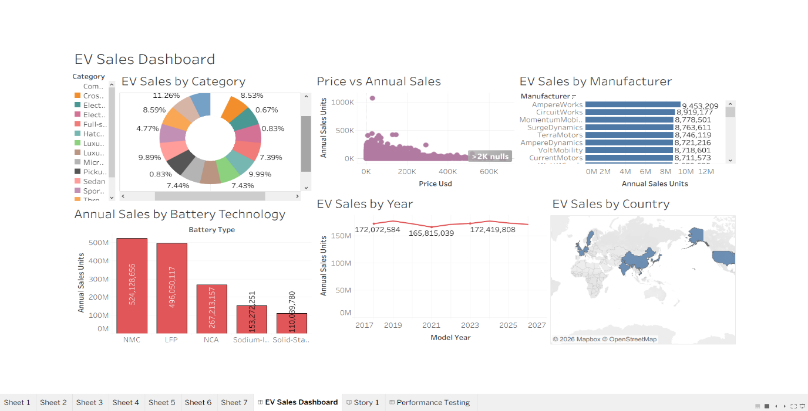

Activity 2: Publish Dashboard on Tableau Public
The Electric Vehicle Market Performance & Insights dashboard was published on Tableau Public to make it accessible online.
Tableau Public Dashboard Link:
https://public.tableau.com/app/profile/navya.rai3458/viz/EVSalesProjectTableau/EVSalesDashboard?publish=yes

